Kelly Gregory
Mrs. McGoorty
Journalism, Period 2
December 7, 2023
The Osage Nation
The Osage were originally from the area of today’s Missouri, Kansas, and Arkansas. Forced removal and signed treaties claimed Osage lands, moving the tribes further west to Oklahoma beginning in the late 1700s. A trio of treaties, a final one signed in 1825 “stipulated that the Osages would stop raids of travelers on their land, in order to allow that the lands to be cleared for the eventual Santa Fe Trail” (“Treaty” 148).
In 1815 there were an estimated 12,000 full-blooded Osage (“Osage” UXL); by 1900, there were only 900 full-blooded Osage (Walker). Mixed-blood and half-blood tribal members strengthen their numbers, but when cultural traditions take on the weight of clarifying authenticity, “[t]he potential danger here lies in not allowing Osage practice to change over time” (Dennison).
With the discovery of some of the largest oil reserves in the country on their land, the Osage again were confronted with hardship and even murder in the early 1900s (“Osage murders”). Nonetheless, the Osage endure looking to past traditions, see Fig. 1, and modern ones, see Fig. 2.

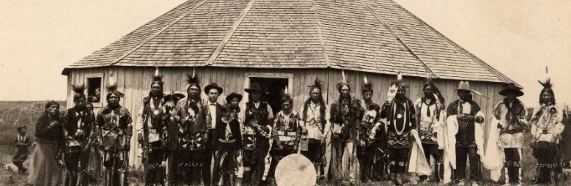  Fig. 1 (“Osage Indian”) | 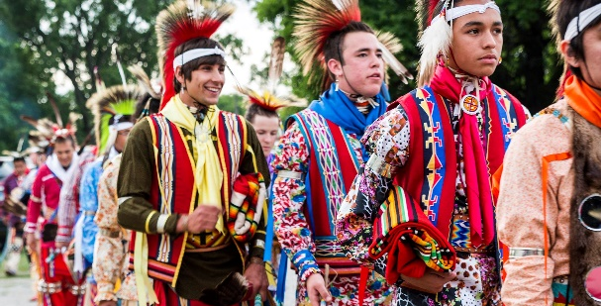  Fig. 2 ("Grayhorse”)
Works Cited
Dennison, Jean. "The Logic of Recognition: Debating Osage Nation Citizenship in the Twenty-First Century." American Indian Quarterly, vol. 38, no. 1, 2014, pp. 1-35. JSTOR, https://doi.org/10.5250/amerindiquar.38.1.0001.
"Grayhorse men in traditional clothing." The Osage Nation, Photo, 2022, www.osageculture.com/culture/multimedia-collections/historical.
"Osage." UXL Encyclopedia of Native American Tribes, edited by Laurie J. Edwards, 3rd ed., vol. 2, UXL, 2012, pp. 833-52. Gale eBooks, link-gale-com.ezproxy.kcls.org/apps/doc/CX4019400062/GVRL?u=kcls_main&sid=bookmark-GVRL&xid=1b347a83.
"Osage Indian Dancers." The Osage Nation, Photo, 1912, www.osageculture.com/culture/multimedia-collections/historical.
"Osage murders." Britannica Library, Encyclopedia Britannica, 1 Sep. 2023. library-eb-com.ezproxy.kcls.org/levels/referencecenter/article/Osage-murders/638676.
"Treaty with the Great and Little Osage (1825)." Indian Treaties in the United States: An Encyclopedia and Documents Collection, edited by Donald Lee Fixico, Santa Barbara, ABC-CLIO, 2018.
Walker, Henry, "A King in this West." The Indian Advocate, 01 April 1903. Lib. of Congress Chronicling America: Historic American Newspapers, https://chroniclingamerica.loc.gov/lccn/45043535/1903-04-01/ed-1/seq-11/.

